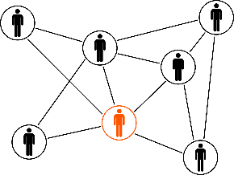

**The 21 Day Leadership Challenge**

© Eye Squared Leadership

Name of Leader: Click or tap here to enter text.

Your leader is interested in learning more about his or her perceived character. You’ve been chosen to provide feedback regarding facts or perceptions when it comes to their character. To assist, please complete the following as honestly as possible. It’s understood that some of your responses will be guesses or simply based upon perception.

*1 = Not true …………. 10 = Very true*

|  |  |  |
| --- | --- | --- |
| **THE CORNERSTONE TEST** | | |
| **1.** | S/He sees potential and value in everyone they meet. | Choose an item. |
| **2.** | S/He does what they say they will do. | Choose an item. |
| **3.** | S/He is transparent with others. | Choose an item. |
| **4.** | S/He treats all people well, even those who have done them wrong. | Choose an item. |
| **5.** | S/He doesn’t talk negatively about others behind their backs. | Choose an item. |
| **6.** | S/He listens more than they talk. | Choose an item. |
| **7.** | S/He is the same person when they’re in the spotlight as when they’re alone. | Choose an item. |
| **8.** | S/He freely admits mistakes and shortcomings. | Choose an item. |
| **9.** | S/He makes difficult decisions, even if the decision will adversely affect them. | Choose an item. |
| **10.** | S/He is kind and patient with others, even those that are hard to get along with. | Choose an item. |
| **11.** | S/He put the interests of others ahead of their personal agenda. | Choose an item. |
| **12.** | S/He gives people honest feedback. | Choose an item. |
| **13.** | S/He is patient with the faults and weaknesses of others. | Choose an item. |
| **14.** | S/He looks for opportunities to spend time with people. | Choose an item. |
| **15.** | S/He often expresses appreciation to everyone (not just those they like). | Choose an item. |

**Additional comments:**

Click or tap here to enter text.